Home Page

* Header

Header Option 1
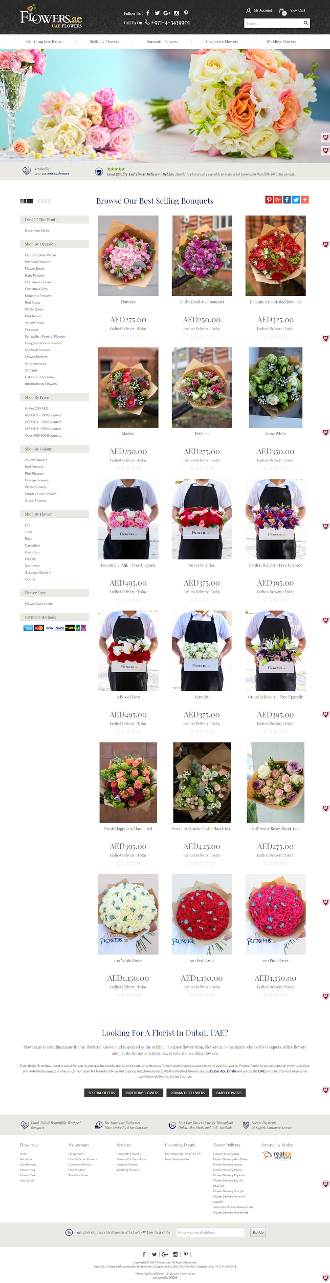
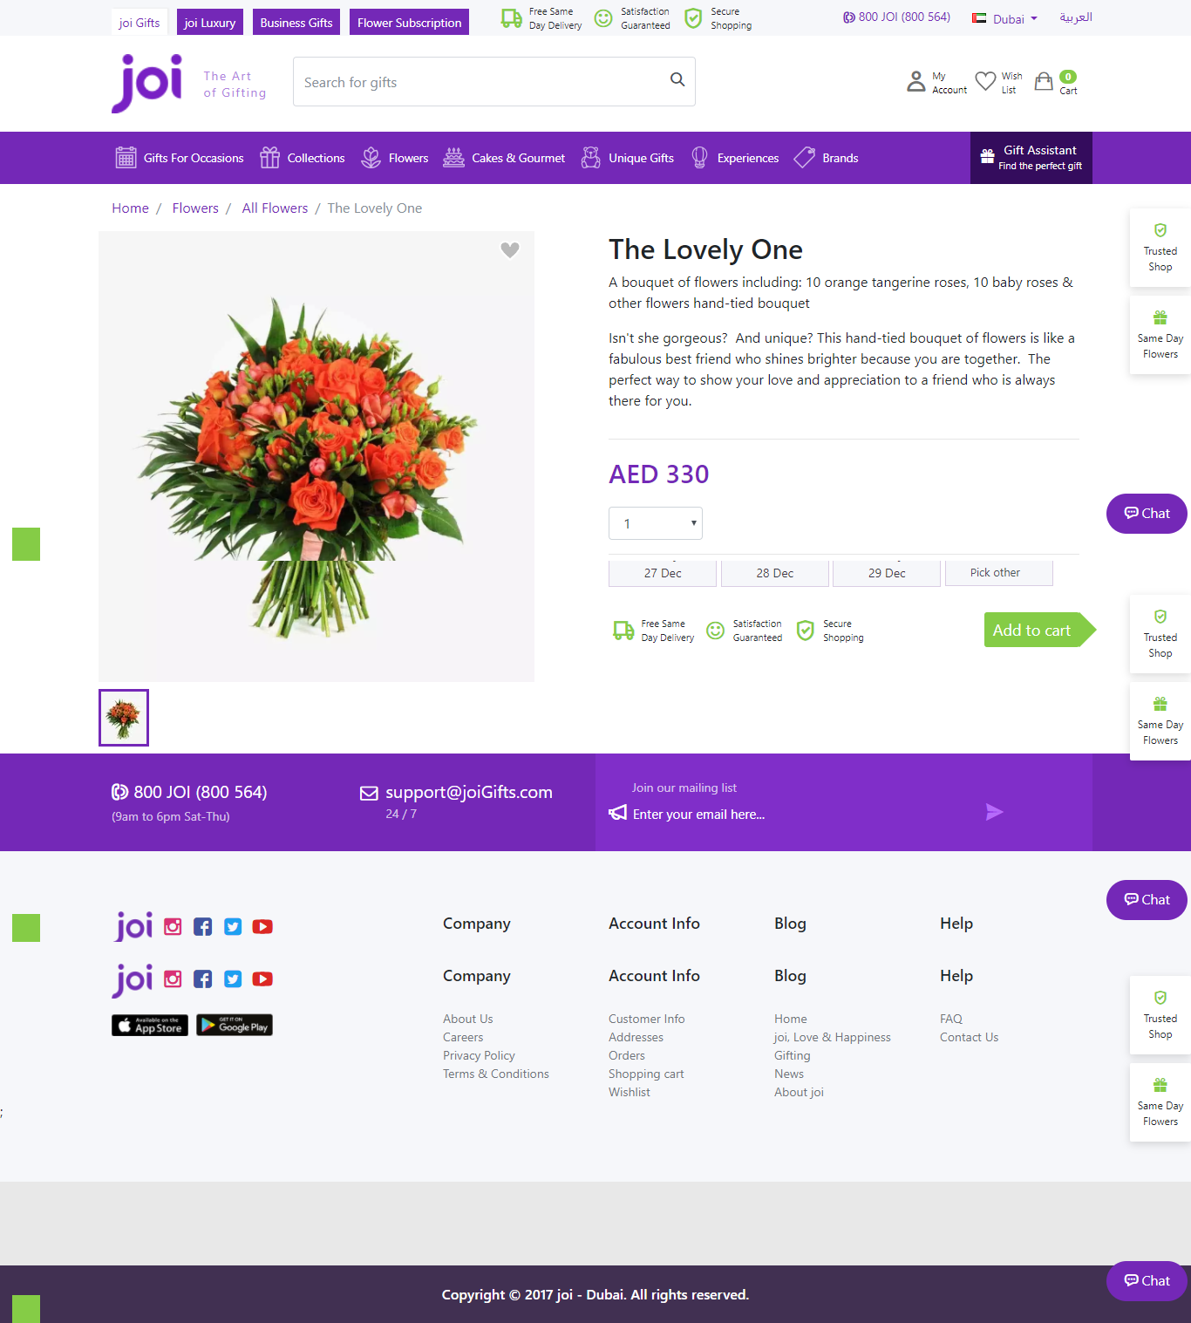

Body

* Carousel

Carousel Option 2
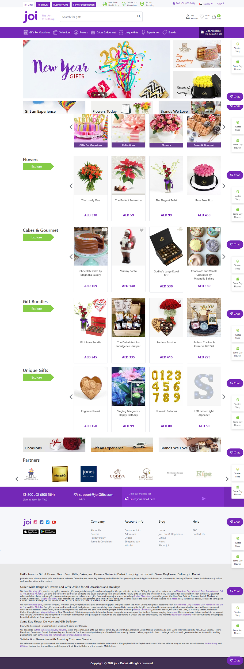

* Menu

Menu Option 1

* Footer

Footer Option 2

Inside Menu (When you click View Button)

View Option 1
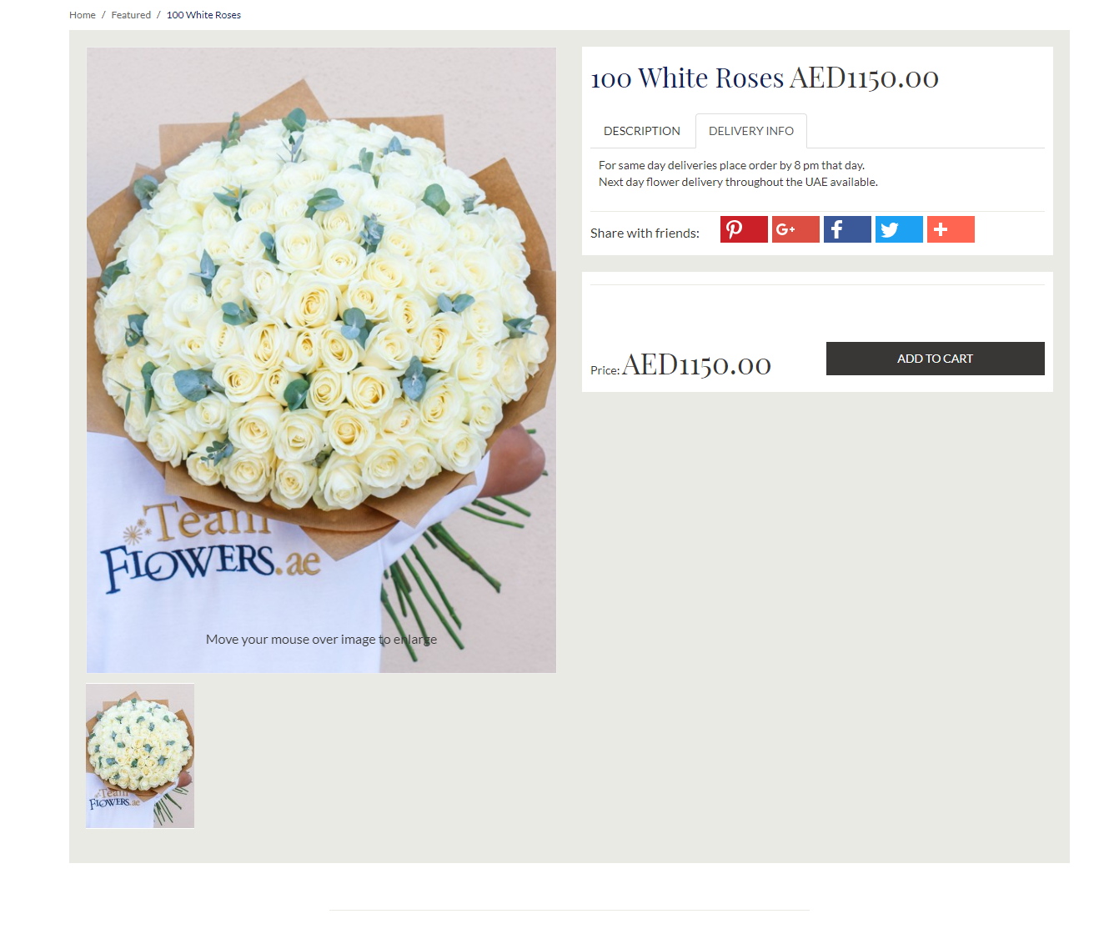
View Option 2

